LAB REPORT

(Names) Bryon Ferrer, Sajana Wijesinghe
(Date) 11/15/18

Title: Lab Number 8
Statement of the Problem:

The question we are trying to answer in this lab session is “How can you use an Arduino microprocessor and it’s software to get a set of wires to vibrate?”

Materials:
- USB Cable
- Arduino Uno microprocessor
- 3VDC Vibration Motor
- Transistor
- Diode
- Capacitor
- Resistors

Procedure:
- First, we’ll begin by setting up our components together as shown in the picture below
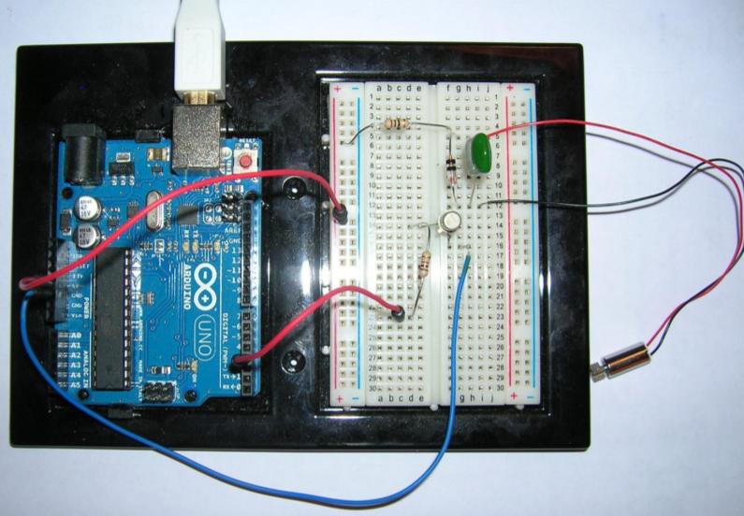

- Once that is done, connect it to PC using the USB Cable.
- If you set up is correct, there should be a light on the Arduino board. This means that the circuit is complete, and current is flowing.
- Next, you add the following code to the Arduino.exe program

const int motorPin = 3;

void setup() {
pinMode(motorPin, OUTPUT);
}

void loop() {
digitalWrite(motorPin, HIGH);
delay(1000);
digitalWrite(motorPin, LOW);
delay(5000);
}

- Afterwards, you’ll have to compile and run it.
- If everything you have done so far has been done properly, the 3VDC Vibration Motor should vibrate

Code:
const int motorPin = 3;

void setup() {
pinMode(motorPin, OUTPUT);
}

void loop() {
digitalWrite(motorPin, HIGH);
delay(1000);
digitalWrite(motorPin, LOW);
delay(5000);
}

Conclusions:

There are a couple of things I learned from the lab. First, I learned about digitalWrite() and how it can apply to many situations involving sensors and other materials. I also learned more about setting up the circuit and making a cycle using resistors and diodes. Finally, I learned about vibration motors and motorPins and how they apply to situations involving resistors and capacitors and such. There is only an experimental error that’s based on setting up the cycle wrong which makes the wires not buzz. Cutting the delay makes the buzz go longer with no stoppage. Other than those things, it was more about buzzing and circuits.

